6 Sports

Reading and writing B
1 Write. Then look and number. (8 points)
basketball alley rink taekwondo
1 do ________________________________ 2 play
3 skating ____________________________ 4 bowling
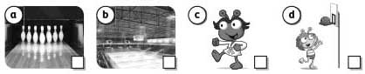
2 Look and write. (9 points)
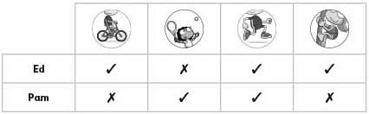
1 Ed run.
2 Pam play tennis.
3 Ed _________________________ climb trees but he play tennis.
4 Pam ______________________ run but she ride a bike.
5 ______________________ Pam climb trees? _________________ , she .

3 Write about your friend’s week. (8 points)
On Monday he/she was .
On Tuesday he/she .
On .

